

***LAB TWO ROLL MILLS***

Professional Laboratory

***Dongguan Amade Instruments Technology Co.,Ltd***

***Amade Technology (Hong Kong) Co.,Limited***

Rubber & Plastics

Mixing Equipment

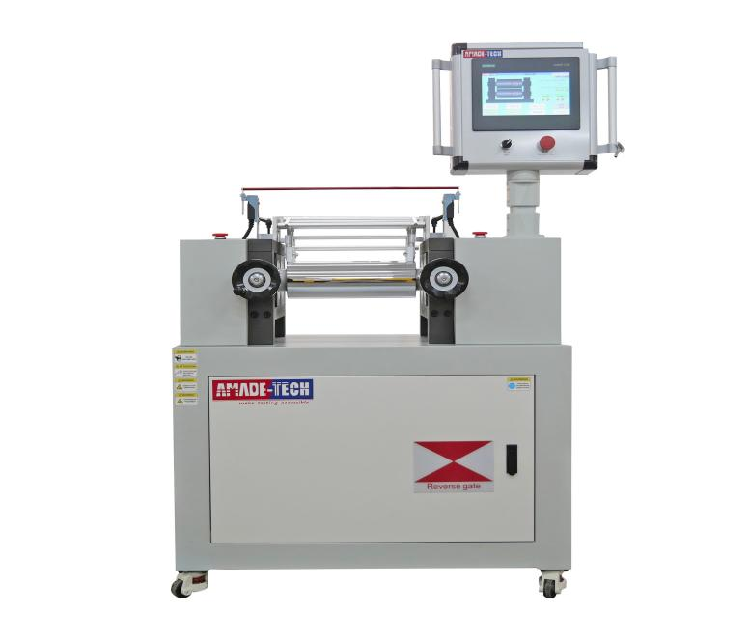

|  |  |
| --- | --- |
| Description |  |

The Lab two roll mills feature two horizontally arranged and rotating rolls to process and mix various polymers in small batches by means of intense shearing action. In the rubber industry, you can use the rubber mixing mill to masticate raw rubber and synthetic rubbers including NBR, SBR, BR, etc. to achieve the required plasticity. In addition, it can also be used to repeatedly disperse and incorporate raw rubber with various additives including accelerators, fillers, vulcanizing agents, etc., to finally obtain a uniform rubber compound for further molding and processing in the laboratory. In the plastics industry, you can used the lab rolling mill to plasticize and mix resins and other additives in small batches to obtain sheet materials of specified thicknesses with even dispersion and good interpenetration between components for laboratory recipe development, color comparison, trial production, molding, aging test, etc.

Lab two roll mill series with different specifications are available at AmadeTech. Welcome to reach us to lean more.

|  |  |
| --- | --- |
| Standards |  |

ASTM D3182

ISO 2393, etc.

|  |  |
| --- | --- |
| Main Technical Specifications |  |

|  |  |
| --- | --- |
| Model | AT-R7024 series |
| Roll dia. | 120 mm / 160 mm / 200 mm / 250 mm and more |
| Roll length | 350 mm / 520 mm / 630 mm and more |
| Roll hardness | 50 ~ 60 HRC |
| Roll temperature | Room temp. ~ 300 °C |
| Heating mode | Electrical heating / oil heating / steam heating (Optional) |
| Cooling mode | Water cooling (Optional) |
| Friction ratio | 1.17:1 / 1.25:1 or customized / adjustable ratio |
| Roll revolution | Constant speed / single frequency modulation / double frequency modulation |
| Roll gap | 0.1 ~ 12 mm adjustable |
| Control mode | Microprocessor / PLC touch screen |
| Power supply | 3-phase, AC 380 V, 50 Hz or transformed to other voltages |